Multiple Choice Questions

1) | Which of the following is formed by oxidation of a DNA base?

A) | uracil
B) | 8-oxoguanine
C) | 7-methylguanine
D) | thymine dimer
E) | all of the above

Answer: B

Difficulty: 2 Topic: DNA Repair

2) | What is the causative agent in the formation of a cyclobutane thymine dimer?

A) | benzo[a]pyrene
B) | N-methyl-N′nitro-N-nitrosoguanidine
C) | methylnitrosourea
D) | ethylmethanesulfonate
E) | ultraviolet radiation

Answer: E

Difficulty: 2 Topic: DNA Repair

3) | Which of the following coenzymes forms the photochemical reaction center of DNA photolyase?

A) | NADH
B) | thiamine pyrophosphate
C) | biotin
D) | FADH⁻
E) | 5-methyltetrahydrofolate

Answer: D

Difficulty: Topic: DNA Repair

4) | Methylation of guanine to produce O⁶-methylguanine (mG) results in what change to DNA?

A) | mG frequently pairs with thymine resulting in a GC → AT mutation
B) | mG loses its methoxy group resulting in hydrogen bonding with adenine and a bulge in the double helix
C) | mG is prone to deamination and eventually, depurination
D) | repair of mG adducts uses a radical mechanism that has the potential to further damage adjacent bases, particularly thymine
E) | none of the above

Answer: A

Difficulty: 2 Topic: DNA Repair

5) | What is the correct order of enzyme activities required for nucleotide excision repair?

A) | exonuclease, helicase, polymerase, ligase
B) | exinuclease, helicase, polymerase, ligase
C) | exonuclease, polymerase, ligase, helicase
D) | exinuclease, polymerase, ligase, helicase
E) | exonuclease, ligase, polymerase, helicase

Answer: B

Difficulty: 2 Topic: DNA Repair

6) | Which of the following types of DNA repair is often coupled with transcription?

A) | photoreactivation
B) | base excision repair
C) | replication
D) | nucleotide excision repair
E) | all of the above

Answer: D

Difficulty: 2 Topic: DNA Repair

7) | Using the figure below, what is the first bond broken in the base excision repair process?
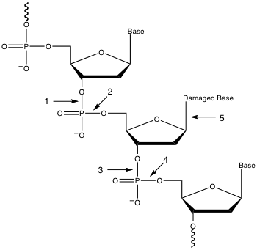
A) | 1
B) | 2
C) | 3
D) | 4
E) | 5

Answer: E

Difficulty: 1 Topic: DNA Repair

8) | Which base or bases is/are methylated to identify the original template strand of replicated DNA?

A) | A
B) | C
C) | G
D) | A and G
E) | C and G

Answer: A

Difficulty: 1 Topic: DNA Repair

9) | Which is a possible outcome when guanine is oxidized to 8-oxoguanine in the following segment of DNA?

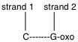

A) | 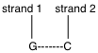 is the only possible outcome
B) | 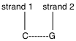 is the only possible outcome
C) | 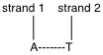 is the only possible outcome
D) | both and are possible outcomes
E) | both and are possible outcomes

Answer: E

Difficulty: 3 Topic: DNA Repair

10) | In mismatch repair coupled to replication, which of the following relates a correct sequence of events?

A) | daughter strand identification, mismatch identification, cleavage of daughter strand, helicase, polymerase, ligase
B) | daughter strand identification, mismatch identification, helicase, cleavage of daughter strand, polymerase, ligase
C) | mismatch identification, daughter strand identification, cleavage of daughter strand, helicase, polymerase, ligase
D) | mismatch identification, daughter strand identification, helicase, cleavage of daughter strand, polymerase, ligase
E) | mismatch identification, helicase, daughter strand identification, cleavage of daughter strand, polymerase, ligase

Answer: C

Difficulty: 2 Topic: DNA Repair

11) | What is a common trigger for the bacterial SOS response?

A) | thymine starvation
B) | DNA cross-linking agents such as mitomycin C
C) | ultraviolet radiation
D) | mutation of DNA replication genes
E) | all of the above

Answer: E

Difficulty: 1 Topic: DNA Repair

12) | The repair of a double-strand break can be accomplished by ______________, which requires the Ku70/80 protein to _______________________.

A) | nonhomologous end joining; catalyze blunt end ligation
B) | nonhomologous end joining; bind to both ends of the break
C) | homologous recombination; catalyze blunt end ligation
D) | homologous recombination; bind to both ends of the break
E) | none of the above

Answer: B

Difficulty: 2 Topic: DNA Repair

13) | The introduction of DNA into a bacterial cell by first packaging the DNA into a phage particle is referred to as _____________.

A) | transduction
B) | transformation
C) | transposition
D) | conjugation
E) | illegitimate recombination

Answer: A

Difficulty: 1 Topic: Recombination

14) | In order for lysogeny to occur, the enzyme ______________ must insert the phage DNA into a specific site in the bacterial chromosome.

A) | ligase
B) | lysogenase
C) | helicase
D) | integrase
E) | none of the above

Answer: D

Difficulty: 1 Topic: Recombination

15) | Which of the following the represents the correct sequence of events for the Holiday model of homologous recombination?

A) | nicking, strand invasion, branch migration, ligation, crossed strand breakage, rejoining
B) | nicking, strand invasion, branch migration, crossed strand breakage, ligation, rejoining
C) | nicking, strand invasion, ligation, branch migration, crossed strand breakage, rejoining
D) | nicking, strand invasion, ligation, branch migration, isomerization, crossed strand breakage, rejoining
E) | nicking, strand invasion, branch migration, isomerization, crossed strand breakage, ligation, rejoining

Answer: C

Difficulty: 2 Topic: Recombination

16) | How does RecA bring about strand exchange?

A) | RecA acts as a helicase, unwinding DNA in localized regions
B) | RecA monomers bind to ssDNA to form a nucleoprotein filament
C) | RecA monomers interact only with ssDNA and immediately dissociate when binding to dsDNA
D) | RecA forms a tetramer that wraps around DNA at specific sites that must be cleaved by a nuclease
E) | none of the above

Answer: B

Difficulty: 2 Topic: Recombination

17) | What role does integration host factor (IHF) play in site-specific recombination during phage λ lysogeny?

A) | binds host DNA forcing a 90° bend
B) | supercoils phage DNA
C) | cleaves host and phage DNA at specific sites to create sticky ends
D) | ligates host and phage DNA once recombination occurs
E) | all of the above

Answer: A

Difficulty: 2 Topic: Recombination

18) | One mechanism to introduce greater diversity into antibody sequences is somatic hypermutation. What enzyme is responsible for somatic hypermutation in the DNA sequences that code for antibodies?

A) | deoxyadenosine deaminase
B) | deoxycytidine deaminase
C) | deoxyadenosine transaminase
D) | purine-pyrimidine transposase
E) | none of the above

Answer: B

Difficulty: 2 Topic: Gene Rearrangements

19) | In antibody light chain production, combination of V and J regions occurs at the _____ level; combination of J and C regions occurs at the _____ level.

A) | DNA; DNA
B) | DNA; RNA
C) | DNA; protein
D) | RNA; RNA
E) | RNA; protein

Answer: B

Difficulty: 2 Topic: Gene Rearrangements

20) | Which of the following transposable elements is correctly defined?

A) | insertion sequence: protein-encoding gene flanked by two insertion sequences
B) | composite transposon: protein-encoding gene + transposase and resolvase genes flanked by two insertion sequences
C) | class II transposon: protein-encoding gene + resolvase gene flanked by two insertion sequences
D) | class III transposon: results from infection of a bacteriophage such as Mu
E) | none of the above

Answer: D

Difficulty: Topic: Gene Rearrangements

21) | A transposable element in a eukaryotic cell is called a _____________.

A) | retrotransposon
B) | long terminal repeat
C) | oncogene
D) | replicative transposon
E) | composite transposon

Answer: A

Difficulty: 1 Topic: Gene Rearrangements

22) | What is contained within a homogeneously staining region?

A) | a series of several replication origins
B) | a sequence of genes all under control of one promoter
C) | tandem duplicates of a specific gene
D) | a region of DNA created by a retrovirus
E) | none of the above

Answer: C

Difficulty: 2 Topic: Gene Amplification

Short Answer Questions

1) Show the common base pair seen between 8-oxoguanine and adenine.

Answer:

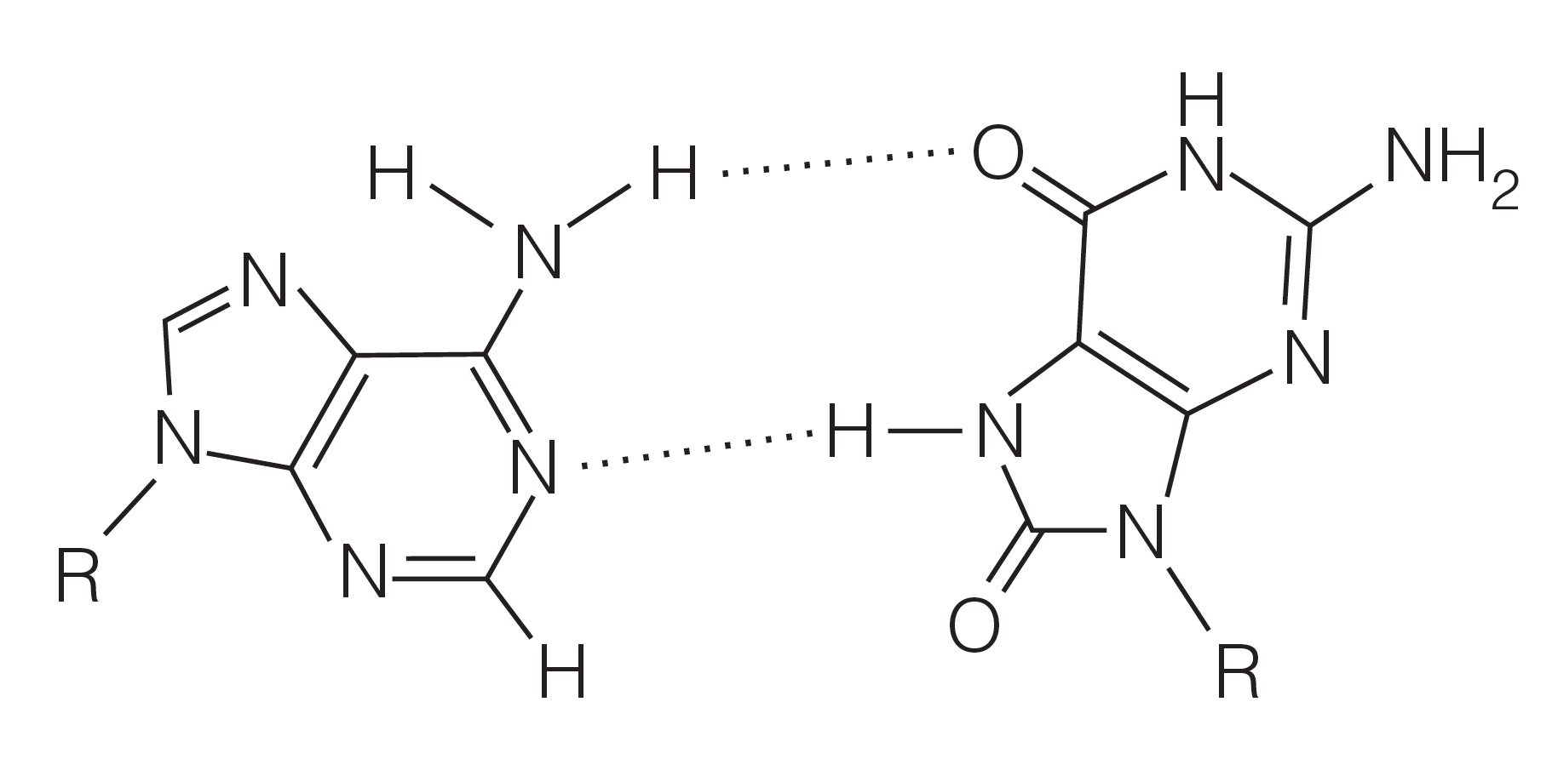

Difficulty: 2 Topic: DNA Repair

2) Using the following DNA segment, show how microsatellite instability is present through a 2-base deletion as a result of loop creation within the A-C repeating sequence. Give the sequence after the first round of replication (with loop) and after the second round of replication.

Template strand: 3’-C-A-C-A-C-A-C-A-C-A-5’

Answer:

There are several possible products from the first round of replication; all will contain some sort of loop structure:

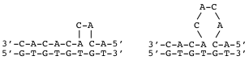

After the second round of replication, the segment will be shortened with elimination of the loop in one of the products:

3’-C-A-C-A-C-A-C-A-5’ 3’-C-A-C-A-C-A-5’
5’-G-T-G-T-G-T-G-T-3’ 5’-G-T-G-T-G-T-3’

For the loop-containing strand, it will most likely be replicated normally:

3’-C-A-C-A-C-A-C-A-C-A-5’ 3’-C-A-C-A-C-A-C-A-C-A-5’
5’-G-T-G-T-G-T-G-T-G-T-3’ 5’-G-T-G-T-G-T-G-T-G-T-3’

Difficulty: 3 Topic: DNA Repair

3) Given the following DNA segments, show the intermediate structure that would be produced following isomerization during homologous recombination.

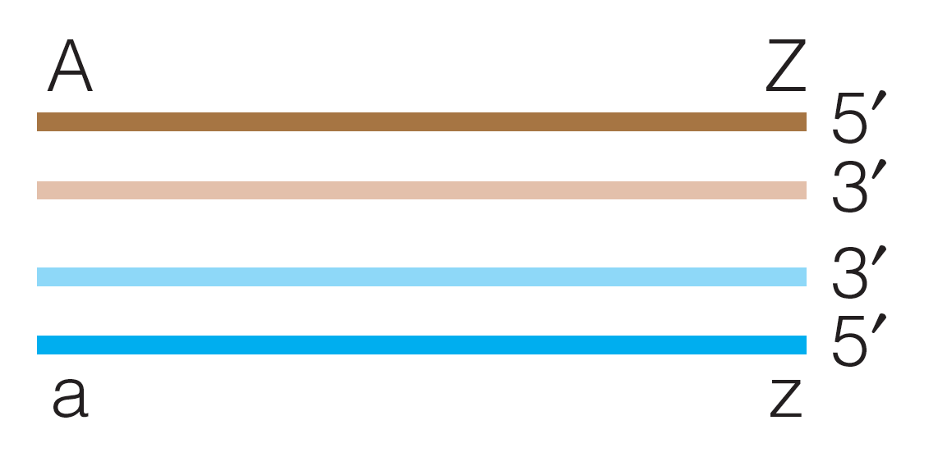

Answer:

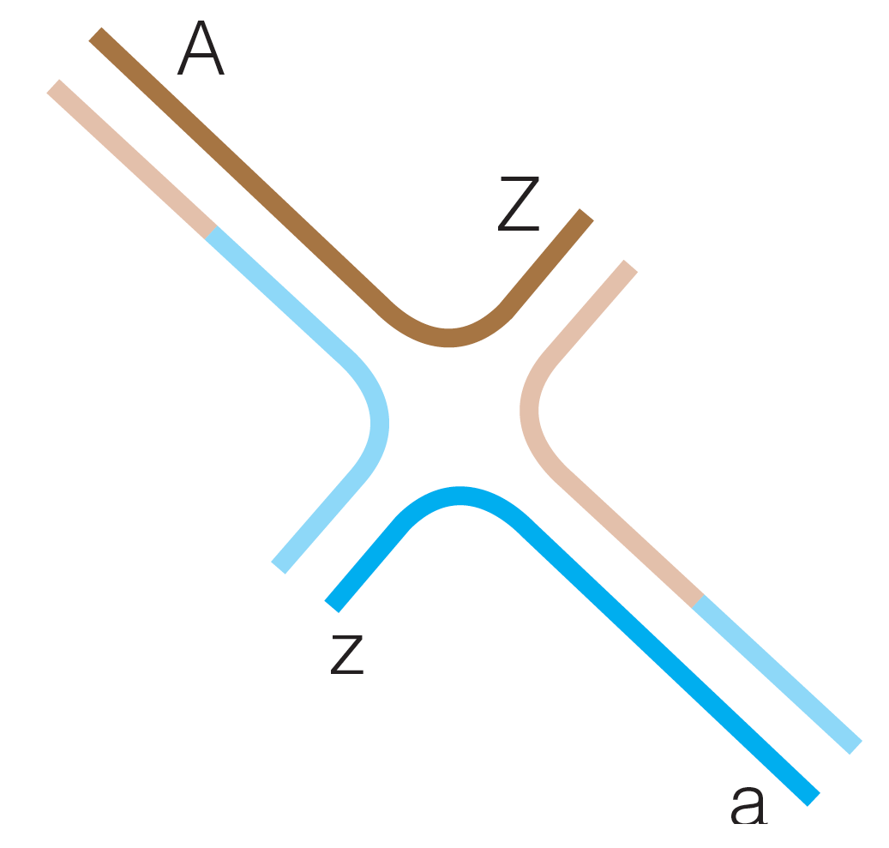

Difficulty: 2 Topic: Recombination

